
McGrath Ultra-Secua Packer Instructions

Important information!!
SLW36 keys must be used
Use with Brava Urban 3162 fixed cam cylinder

Standard fixed cam cylinder will need to have the cam timing changed to fit.

Step 1: Remove circlip from 1 side only of the cylinder.
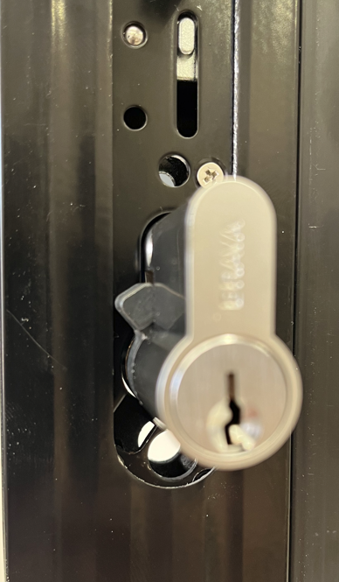

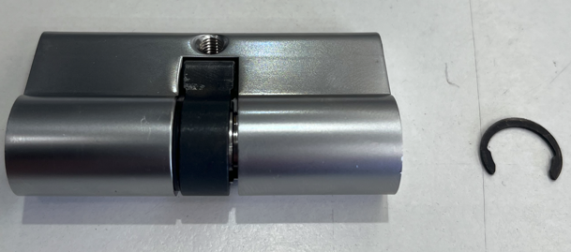

Step 2: Turn the key slightly to prevent top pins locking into the wrong chamber. (note leave key in the cylinder during these next steps)

Step 3: Slightly pull plug out slowly until cam can move freely and rotate cam to point downward. (be careful not to pull the plug out too far)

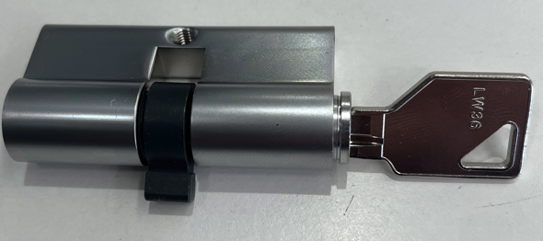
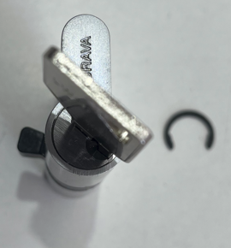

Step 4: Turn the cam around while lightly putting forward pressure on the plug until the cam aligns correctly and plug can slide back into the cylinder.

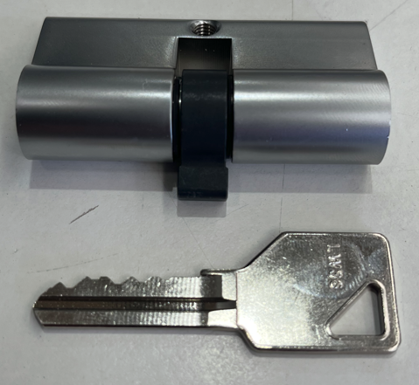
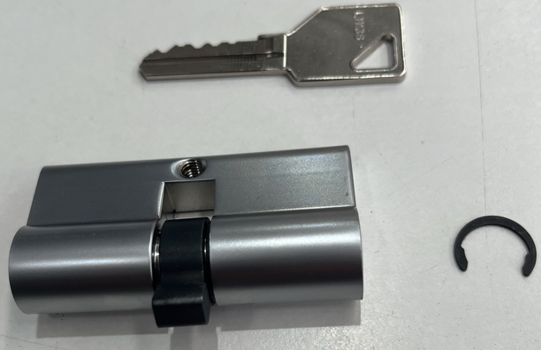

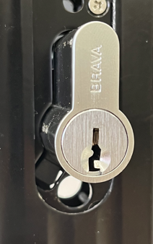
Step 5: Re-install circlip.

Step 6: Cylinder can now be installed into the
Ultra-Secua lock body.

Step 7: Place packer on the Ultra-Secua
external handle and install lock from original installation instructions.

